WEEK 5
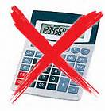
- Helen has 24 red apples and 12 green apples. What fraction of the apples are green?
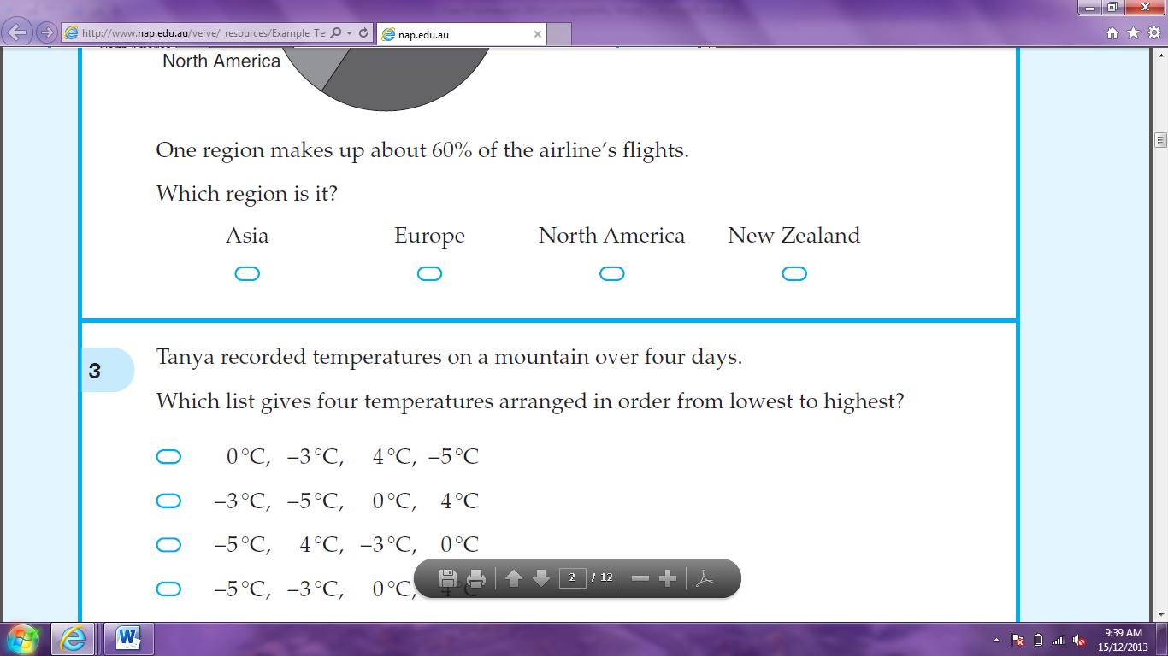




- Which number is the largest?




0.3 0.05 0.006 0.123

- Kevin made these 2 objects by gluing cubes together face-to-face.
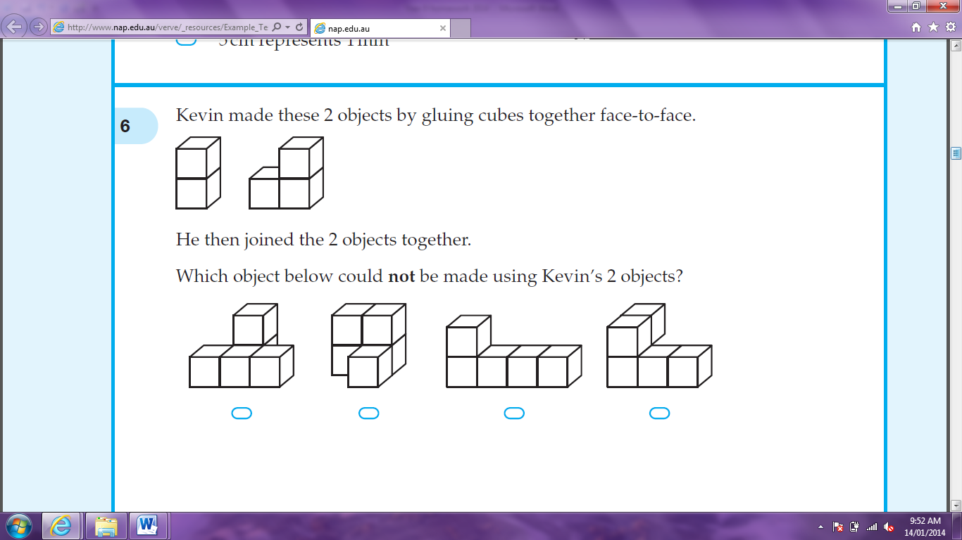

He then joined the 2 objects together. Which object below could not be made using Kevin’s 2 objects?


- Five students compared their heights. The diagram below shows their results. Which student is the tallest?
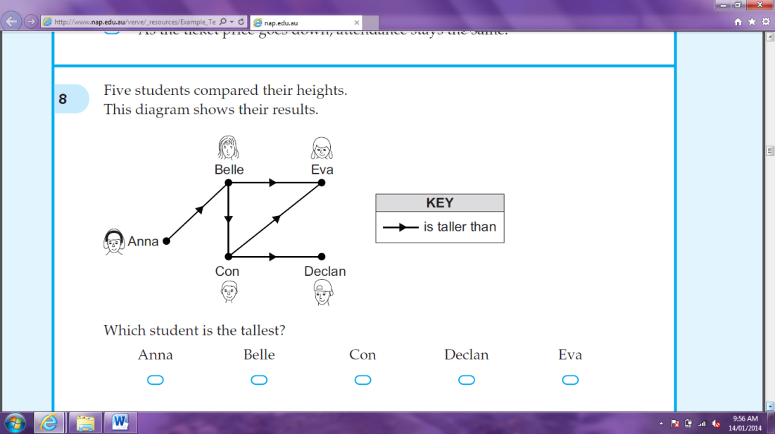

- Write 5 cents as a faction of a dollar, in simplest form.

- Which is equivalent to 3t + 2t + 4t?




9t 24t 9t³ 24t³

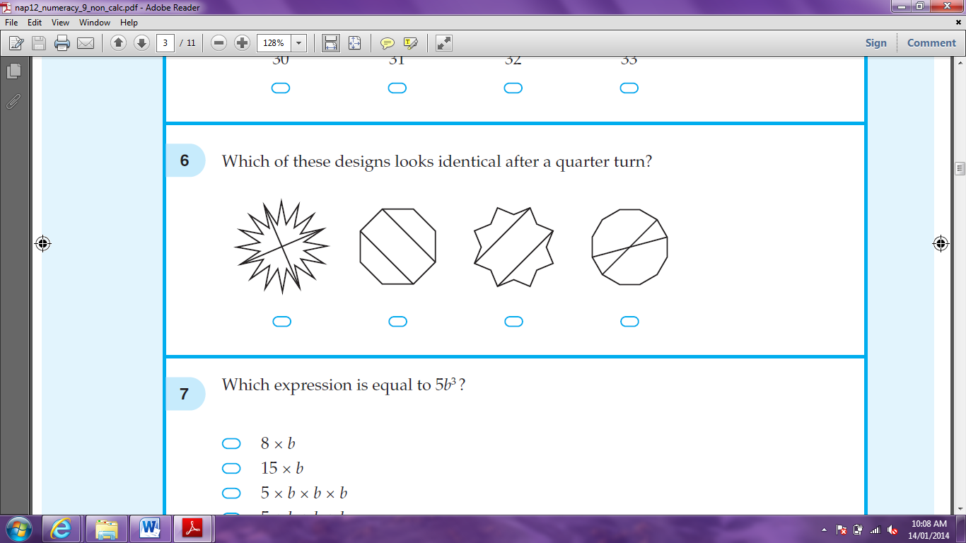
- Which of these designs looks identical after a quarter turn?

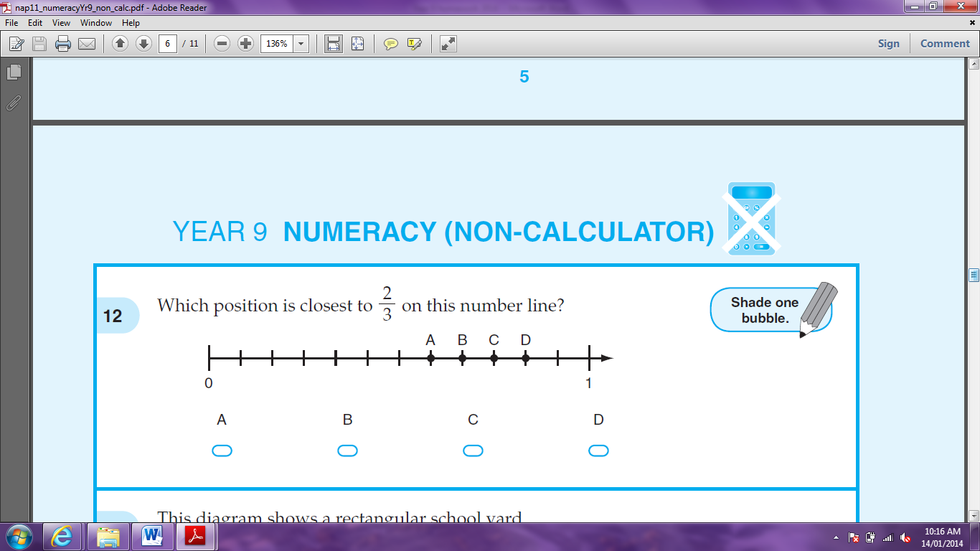
- Which position is closest to on this number line?





A B C D
- What is 12 ÷ ?

- For which object is the sum of the number of edges and number of vertices three times the number of faces?




triangular prism triangular pyramid rectangular prism rectangular pyramid

- Terry bought 7 boxes of pencils. In total this was 84 pencils. Which equation correctly shows n as the average number of pencils?




84 x 7 = n 84 – 7 = n n ÷ 7 = 84 n x 7 = 84

- A plane arrived in Hobart at 1:20pm after hour flight from Brisbane. What time did it leave Brisbane?

- Jade buys a 500 gram bag of beads at a market. Each bead has a mass of 0.48 grams. Which is the best estimate for the number of beads in the 500 gram bag?




100 250 1000 2500

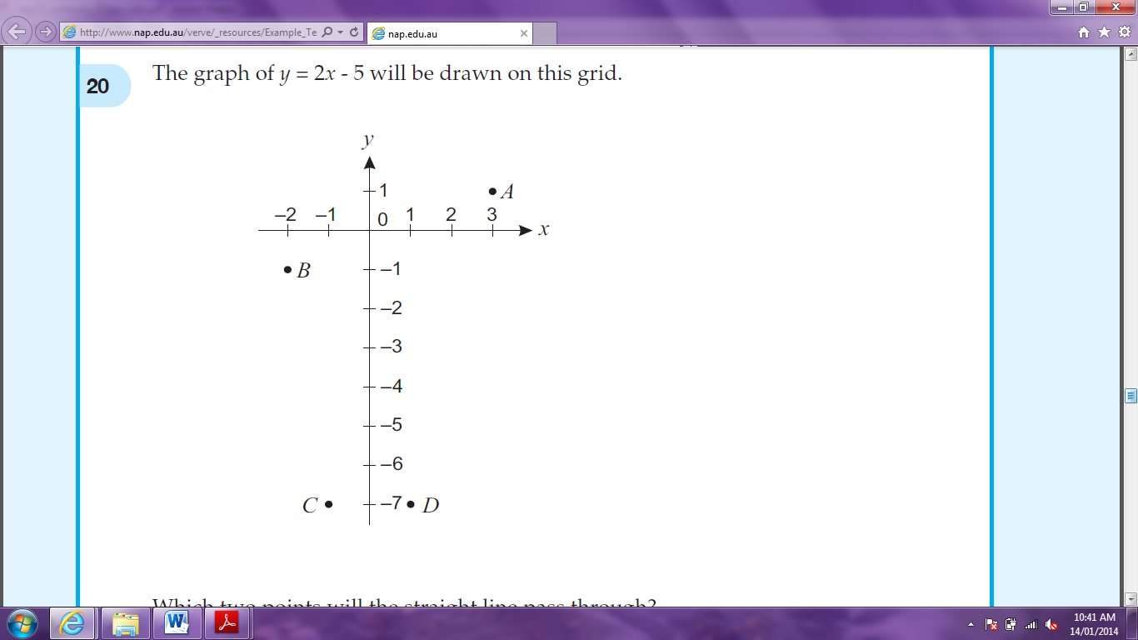
- The graph of will be drawn on the grid below. Which two points will the straight line pass through?

- The height (h metres) and age (a years) of a tree are related by the following inequality:
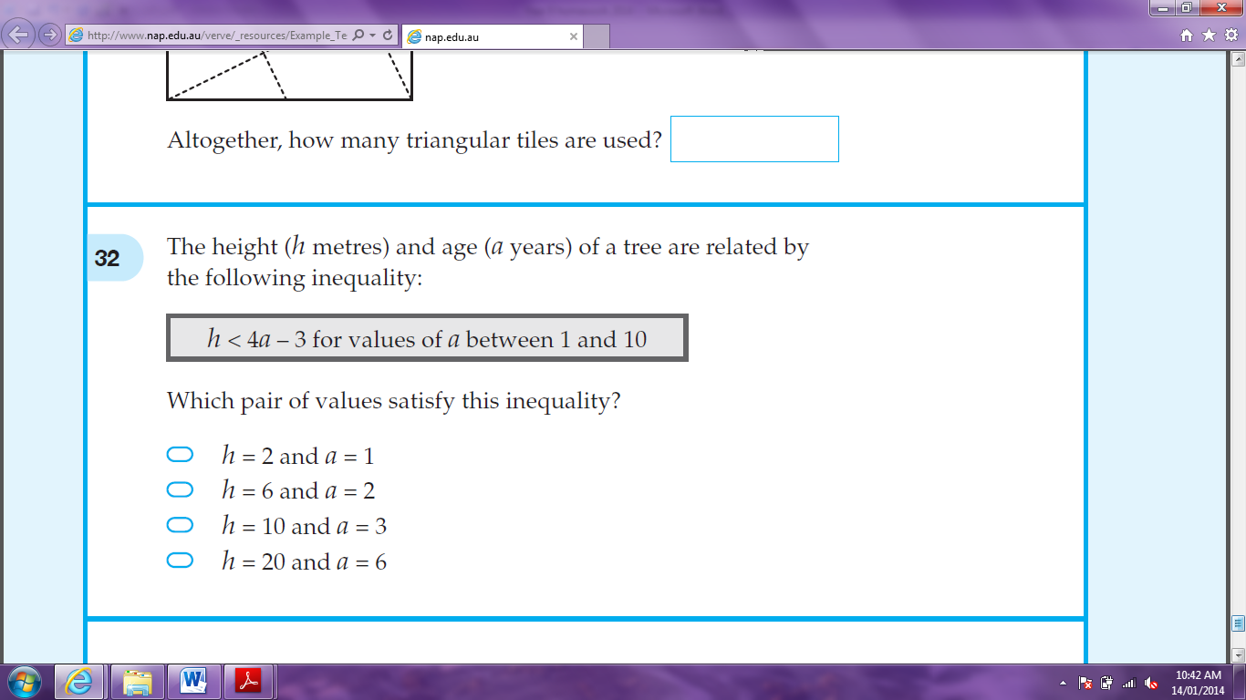

Which pair of values satisfy this inequality?




h = 2 and a = 1 h = 6 and a = 2 h = 10 and a = 3 h = 20 and a = 6

- If k = -3, what is the value of k² – 4k?

